STEM CLUB 2023-2024 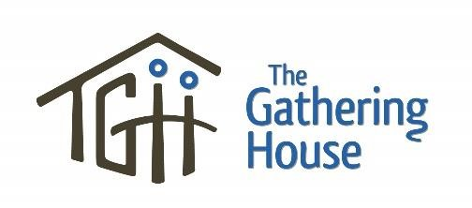

Name of Child: ____________________________________________________ Age: __________
Date of Birth: __________________________________ Grade in September _________________________
Gender: _________ Address: __________________________________________________________ Medical Information
Health Card #: __________________________________ Doctor’s Name _____________________________
Please indicate any special needs, allergies, health conditions (diabetes, behavioural concerns, etc) or other pertinent medical or behavioural information. We welcome children with special needs but do ask that a parent/guardian accompany them. Please contact tghchristinakozmin@gmail.com for more info
____________________________________________________________________________________

Parent or Guardian: ___________________________________ Relationship: _________________________
Phone: __________________ Other:__________________ e-mail___________________________________
Secondary Contact: _______________________________ Phone: ______________________

Important Notes:
STEM club starts at 6:30-7:45pm
Cost-Suggested donation of $50 per child

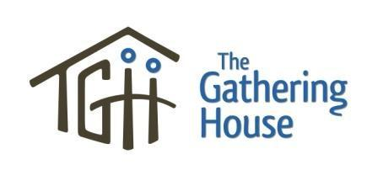
Required Signatures

Permission to Participate
I, the legal guardian or custodial parent of __________________________________, give my permission for
Name of Child
him/her to participate in The Gathering House children’s program.

_____________________________________________ ___________________________
Name of Parent/Guardian (please print) Date

_____________________________________________________________________
Signature of Parent/Guardian

Medical Release and Waiver
In the event that my child requires special medication, x-rays, or medical treatment, I understand that I will be notified immediately. In the event that I am not able to be contacted and my child requires immediate medical treatment, I give permission to the physician selected by The Gathering House to hospitalize and/or provide proper medical treatment to my child. I understand that this could include injections, anaesthesia, or surgery.

Waiver
Understanding that precautions are taken for the safety and health of my child while participating in The
Gathering House children’s program, I hereby release from any liability The Gathering House, its staff and its volunteers in the event of sickness or injury incurred by my child during this program.

_______________________________________ ______________________________
Signature of Parent/Guardian Date

Photos
I give permission to The Gathering House to publicly use any photos in which my child appears to highlight our events and promote future events (website, posters, displays etc.)

_______________________________________ ________________________________
Signature of Parent/Guardian Date

